Neonatal Kitten

Foster Handbook

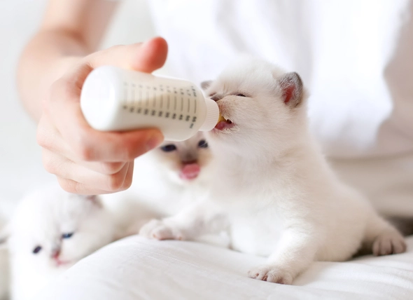

A guide to helping us save one tiny life at a time.



Table of Contents

Welcome and Introduction……………………………...…3-4
Procedures for Pickup and Return……………………….…5
Safeguarding Kittens and Your Pets………..……………..6
General Care of Bottle-Feeders…………………………7-13
- Housing………………………………………………...7-8
- Pottying……………………………………………....8-10
- Kitten Hygiene…………………………………...…10-11
- Bottle-Feeding……………………………………...11-13
- Troubleshooting Fussy Feeders……………....……..13
Weaning Kittens……………………………………………..14
Kitten Health……………………………………………..15-17
- Record Keeping……………………………………......15
- Vaccination Schedule..….………….…………..…15-16
- Common Problems ………………………………..16-18
Emergencies…………………………………………..…….19
Helpful Charts…………………………………………...20-21

Welcome and Introduction

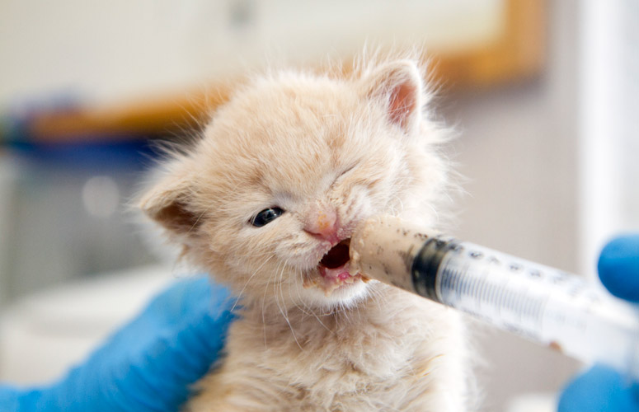

Welcome to the team of dedicated foster parent volunteers (AKA life savers) of the Idaho Humane Society!

So you are interested in becoming a foster mom or dad to an orphaned kitten- that’s a great start! It may seem overwhelming at first, but with the right preparation, you might be surprised how quickly you can master everything from bottle feeding, to socialization, to litter training.

Underage kittens are the most vulnerable population of animals that enters our shelter doors. They need around the clock care and are susceptible to getting sick in the shelter setting. That means that their only hope of surviving to adoption day is a foster family.

With your help, the Idaho Humane Society can help hundreds of orphaned kittens each year. Some need intensive bottle feeding, and some just need the gift of time and space to grow until they can be spayed and neutered and adopted into loving, forever homes.

Is fostering for you?

Fostering requires a flexible schedule and a personal commitment to the kittens. Have an honest discussion with yourself and your family members about how much time and effort you can dedicate to the kittens. Everyone’s lifestyle is different, and we understand that! Even if you are busy, we may be able to match you with a foster pet to help us save more lives, but bottle-feeding kittens might be too much work for you and that is okay! However, if you do have the time for our tiniest patients, the experience can be so rewarding. We have listed the types of kittens to foster from MOST time intensive, to least!

Bottle-feeders- you will need to allow enough time to:
- Bottle feed the kittens every 2-4 hours (depending on their age) around the clock.
- Clean and/or bathe them as needed.
- Medicate them if they become sick and our veterinarians prescribe treatments
- Transport them to and from the shelter for check-ups as needed
- Play with, cuddle, and socialize the kittens as they develop into tiny cats!

Weaning Kittens//Socializers- you will need to allow enough time to:
- Feed the kittens slurry or wet food every 4-6 hours
- Clean the kittens as needed and keep their enclosures clean. These kittens can be the messiest as they learn how to eat and play (sometimes at the same time!)
- Medicate them if they become sick and our veterinarians prescribe treatments
- Transport them to and from the shelter for check-ups as needed
- Socialize! This is the most important socialization period for kittens so lots of cuddling and play is necessary for normal cat behaviors

Queens and Kits- you will need to allow enough time to
- Feed the family every 8-12 hours
- Help mom keep the kittens clean if she is overwhelmed or slacking on their hygiene a bit
- Clean the litter box daily
- Play, cuddle, and socialize the kittens! Sometimes, queens are less social with humans depending on their background, so it is important to help the kittens learn that humans are safe and fun. This will help make them excellent house cats in the future.

Procedures for Pick-up and Return

Once you have completed the foster orientation and training, you are ready to foster kittens. Let the Foster Department know that you are interested in fostering kittens, and specify which age groups you would be comfortable fostering. We will then place you on our email alert list and sound out a message notifying you of kittens that need foster placement when they arrive. We also have a Facebook group where we can post available foster animals in real time. If you would like to joint the group, let us know! After you respond to your email, we will arrange for a convenient pick-up time. Please understand that for the sake of the kittens, we must place them in homes as soon as possible, usually within hours of arriving at our shelter. It will be a first-come first-serve basis. Do not be discouraged if you miss out on a few litters. We will be busy all summer long and you will be sure to get your share of kitten love.

When the kittens are approaching their 1.5 lb weight goal, please contact the foster coordinator to schedule a date for their return and spay/neuter surgery. Prepare yourself and your family for a bittersweet day- adoption day! It can be a little sad to see your kittens graduate to spay/neuter but congratulate yourself on a job well done and relish in the thoughts of your kittens in their forever homes. If given permission, you may have the option of adopting them out of your home, if you have found family or friends who are interested in adopting the kittens. You will of course have first dibs if you wish to adopt a kitten! We affectionately call this “foster failure”, and it happens to the best of us, but remember, the more kittens you can foster, the more lives you can save!
Safeguarding Kittens and Your Pets

We are committed to the health of your own pets and our foster kittens. There are some important steps to take to keep both healthy and happy. Adult cats can carry diseases that could make vulnerable, neonatal kittens sick, and vice versa depending on what the kittens were exposed to prior to entering your care.

The Idaho Humane Society requires that all foster volunteers have their personal pets vaccinations current. As an added precaution, orphaned foster kittens MUST be kept separated for a minimum of 2 weeks. After this 2-week period, use very cautious judgement. Adult cats may have never been exposed to neonatal kittens and react to them unpredictably. Dogs also may react to young kittens with a very strong prey drive even if they are good with adult cats. Neonatal kittens to not move or react the same way as adult cats and can cause unpredictable reactions in dogs and other personal pets. The last thing we want you to have to deal with is a traumatic encounter between foster kittens and your beloved pets.

The period of 2 weeks is sufficient time for foster kittens to become symptomatic with most diseases they may be incubating. However, some diseases such as Feline Leukemia Virus (FeLV) and ringworm can take much longer to exhibit symptoms. In general, we recommend always keeping foster kittens separate from your personal pets. Having a separate room is ideal. Additionally, there should be no sharing of toys, bowls, litter boxes or food between foster kittens and your pets. As a reminder, the Idaho Humane Society is not responsible for the health of your personal pets, so adhering to best practices is in your best interest.

Good personal hygiene is strongly recommended before and after contact with foster kittens. Washing hands with soap and warm water is sufficient. Cleaning enclosures and your home between litters is also recommended. After you have returned a litter to IHS, sanitize the area. We prefer to use an accelerated hydrogen peroxide product called Rescue. Ask the foster department and we can lend you a bottle. A diluted bleach solution 1:16 also works well.

General Care of Bottle Feeders

Housing

Kittens need a warm, soft, safe nesting place to mimic the nest that a queen would typically make for her kittens. They would normally stay in this nest until 6-8 weeks of age.

- Nesting box
An open topped tupperware box, cardboard box, or airline-style kennel is ideal for housing neonatal kittens as its temperature can be easily regulated and neonatal kittens do not need a lot of space. As the kittens age and become more mobile, small dog kennels, play pens, or other larger enclosures can be fashioned for the kittens.

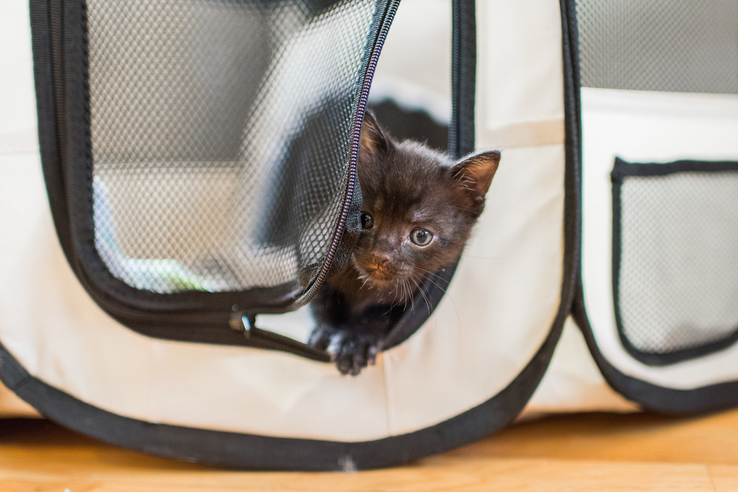

2. Soft bedding
Blankets and towels should be used to line the kitten nesting box to mimic the natural nest and insulate the kittens.

3. Heat supplementation
Hypothermia is the single greatest danger to orphaned neonatal kittens. Kittens cannot regulate their body temperatures reliably until 4 weeks of age. Supplemental heating is required for all nesting areas.

We will provide heat disks that can be heated in the microwave for 3-5 minutes at a time (check the instructions on the disk and the power of your microwave). After heating, the disks can stay warm for up to 8 hours. Always place the protective fleece cover on the disk and always allow for space in the nesting box for the kittens to move AWAY from the disk if they are too warm.

Feeding a cold kitten is extremely dangerous and can impair their ability to swallow properly. If you suspect a kitten is chilled, place it on a warming source until sufficiently warm prior to feeding.

Pottying

Neonatal kittens cannot urinate or defecate on their own. In the wild, queens stimulate each kitten by grooming and licking around their genitals to help them to relieve themselves. Orphaned kittens need our help to do this since they do not have mothers. Kittens will begin to explore the litter box and urinate and defecate on their own around 4-5 weeks.

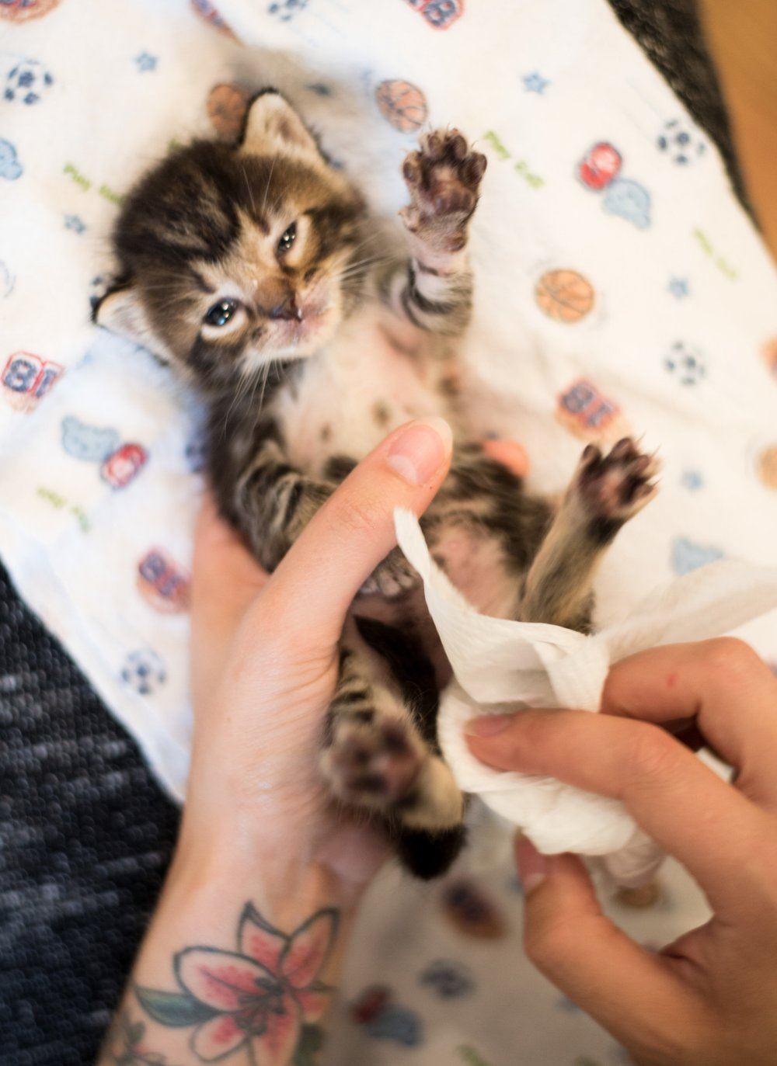

1. Stimulate the kitten with a soft, absorbent tissue

At each feeding, stimulate the kitten to use the bathroom. Use a soft, absorbent, disposable cloth (tissues or toilet paper work great), avoiding harsh products like heavy paper towels which could irritate the kitten's skin. While some people opt to wet the cloth with warm water, this step sometimes isn't necessary as long as the cloth is soft.

The body position for stimulating kittens can vary. Some people prefer to sit the kitten upright on a table, some prefer to hold them upright with their bottom facing the floor, and some prefer to turn them on their back. Find the position that works best for you and the kitten.

Hold the kitten steady with one hand, and gently rub the genital region in a circular motion with your soft tissue. The kitten should begin to pee. Continue to stimulate the kitten until she is no longer peeing. Depending on the kitten's age, this may take anywhere from 10 to 40 seconds.

If the kitten needs to poop, stimulate their bottom the whole time that they are pushing. Stimulating helps encourage them to use their muscles to pass stool, so continue until the kitten has finished her business.

2. Keep a regular schedule and monitor for issues
Stimulate the kitten before and after each feeding to help keep them on a healthy and regular schedule. Follow the weight and feeding chart to determine the frequency of feeding, and monitor the urine and stool for any concerning symptoms.

Urine should be very light yellow to clear. If the urine appears darker, it may indicate that the kitten is dehydrated or having other issues.

Feces should be a light brown/yellow color. The consistency should be anywhere from soft serve to gently formed. Very hard stools, or pure liquid are not normal and could be signs of health issues.

If you're concerned about the frequency or consistency of the kitten's poop, please read more about healthy kitten poop and consult a veterinarian.

3. Bathroom hygiene

After the kitten has urinated and/or defecated, be sure to wipe the kittens genital area with a soft, wet cloth such as a baby wipe. Even if the kitten looks or feels dry, do this each time. Kittens have very sensitive skin and are more prone to urine or fecal scalding.

Hygiene

Cleaning the kittens, especially surrounding feeding, and bathroom times, is very important. Kittens cannot keep themselves clean and normally have a mother that takes this job very seriously. Clean kittens’ faces after each feeding with a soft wet cloth to remove all remnants of formula. Failing to do this can lead to crusting around the kittens’ mouth and face. These crusts are irritating to the skin, and can lead to hair loss, and skin infections.

Wiping kitten behinds after each potty time is also important for the aforementioned reasons. This is especially important if the kitten is having bathroom issues such as diarrhea.

Cleaning in between can be done with a soft toothbrush as this mimics momma’s tongue. It will help you bond with the kitten and replace normal socialization behaviors. The brush can help remove crusted formula, and any other debris from the kittens coat.

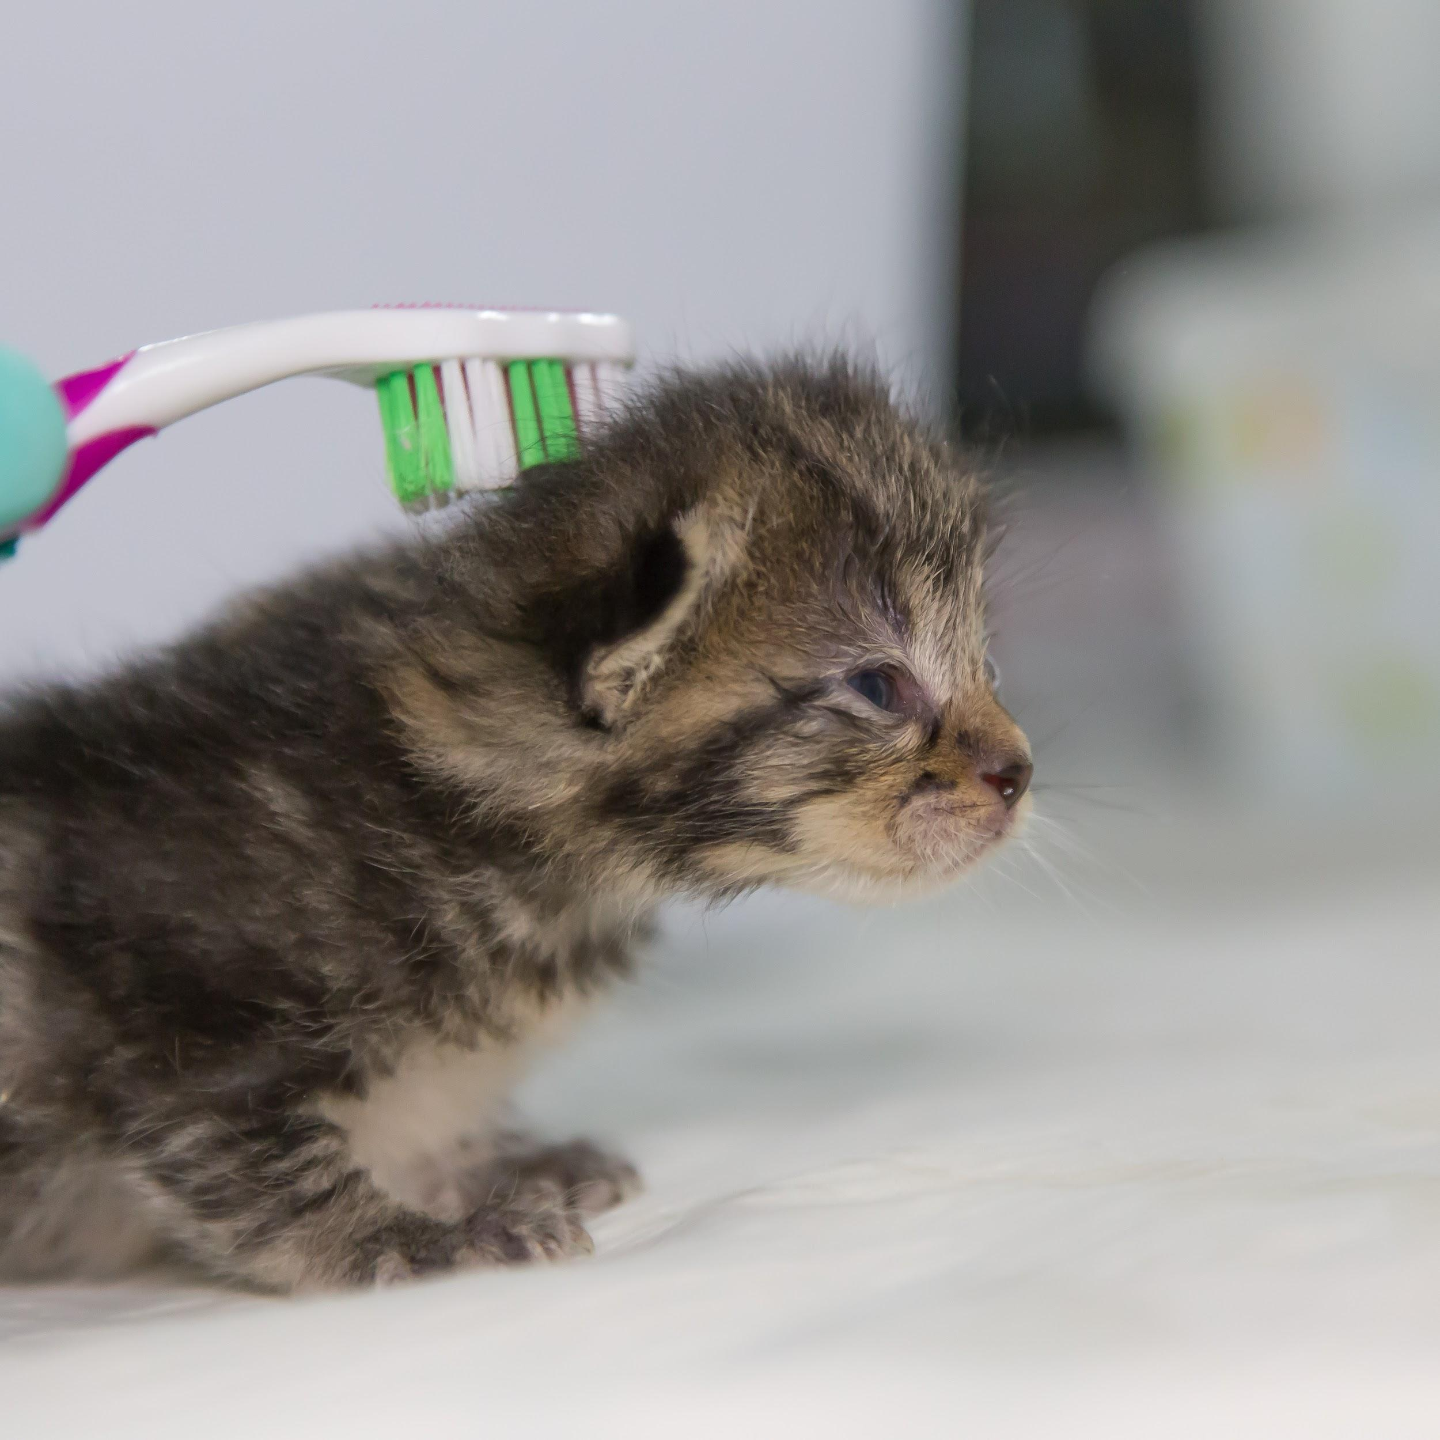

Occasionally, baths may be required. Avoid baths if at all possible in the first few weeks of life as they predispose the kitten to life threatening hypothermia. However, sometimes certain health conditions such as diarrhea, and/or fleas make it a necessity. If you think your neonatal kitten needs a bath, please check with a foster coordinator and/or veterinarian. Bathe with warm water and gentle baby shampoo, then quickly dry the kittens with a hair dryer on warm setting in a warm environment.

Bottle Feeding

1. Prepare a Bottle and Nipple
We will provide bottles and appropriate rubber nipples for kittens. Be aware that the nipple that comes with some bottle kits is not cut; you will need to cut a hole in it yourself or have a foster coordinator help you cut the nipples prior to bringing the kittens home if you are unsure. Miracle Nipples are highly recommended and well accepted by kittens. These come with a hole already. Ask your foster coordinator if you are not sure. The hole should be big enough that if you hold it upside down, formula can slowly drop out of it -- but not so big that it flows out freely. Holes that are too small may result in fussy, frustrated kittens. Holes that are too big can cause aspiration of milk and predispose the kittens to pneumonia.

2. Assess the kitten
Before you feed a kitten, always make sure you've assessed her to make sure it is safe to feed. If a kitten is overheated or too cold, it is not safe to feed until you have gently stabilized their temperature. If a kitten is not able to swallow, it is not safe to feed. Be sure that you've assessed the kitten's temperature and body condition before feeding, especially if it is the first time you are feeding this particular kitten.

3. Fix a Bottle with Formula
We will provide you with kitten milk replacer. This formula is specially designed to mimic cat’s milk and is everything a kitten will need to thrive and grow if fed appropriately. Never feed a kitten cow's milk or other dairy products, dairy alternatives, or human baby formula, as this can be dangerous or even fatal to the kitten. Drop in to pick up more if you are running low! Once opened, keep the dry formula refrigerated.

The brand that we use requires a 2:1, water to formula ratio. Check the label to ensure you are mixing correctly. It is very important to stick to this recipe as different dilutions of the milk can cause issues such as dehydration, diarrhea, and malnutrition. Use a blender bottle (like the ones weight-lifters use for protein shakes), a magic bullet or other blender, or whisk to mix up the formula very well. Clumps can clog the bottle and cause kittens to choke on powder.

Warm the filled bottle by submerging it in warm water. NEVER microwave bottles as this can cause patches of boiling milk that will scald the kittens’ mouths and throats. Kittens will only drink well if the milk in close to body temperature. Check the bottle by dripping milk on your wrist. It should feel like nothing. If it feels warm- milk is too warm. If it feels cold- milk is too cold.

4. Feed the Kitten
Lay the kitten in a natural, belly-down position -- never, ever on her back like a human baby. Hold the kitten's head stable with your non-dominant hand. Gently slide the nipple into the kitten's mouth and invert the bottle to start the flow of formula. The kitten should roll her tongue into a U-shape and begin to swallow. Follow the feeding chart for a guideline of amount and frequency.

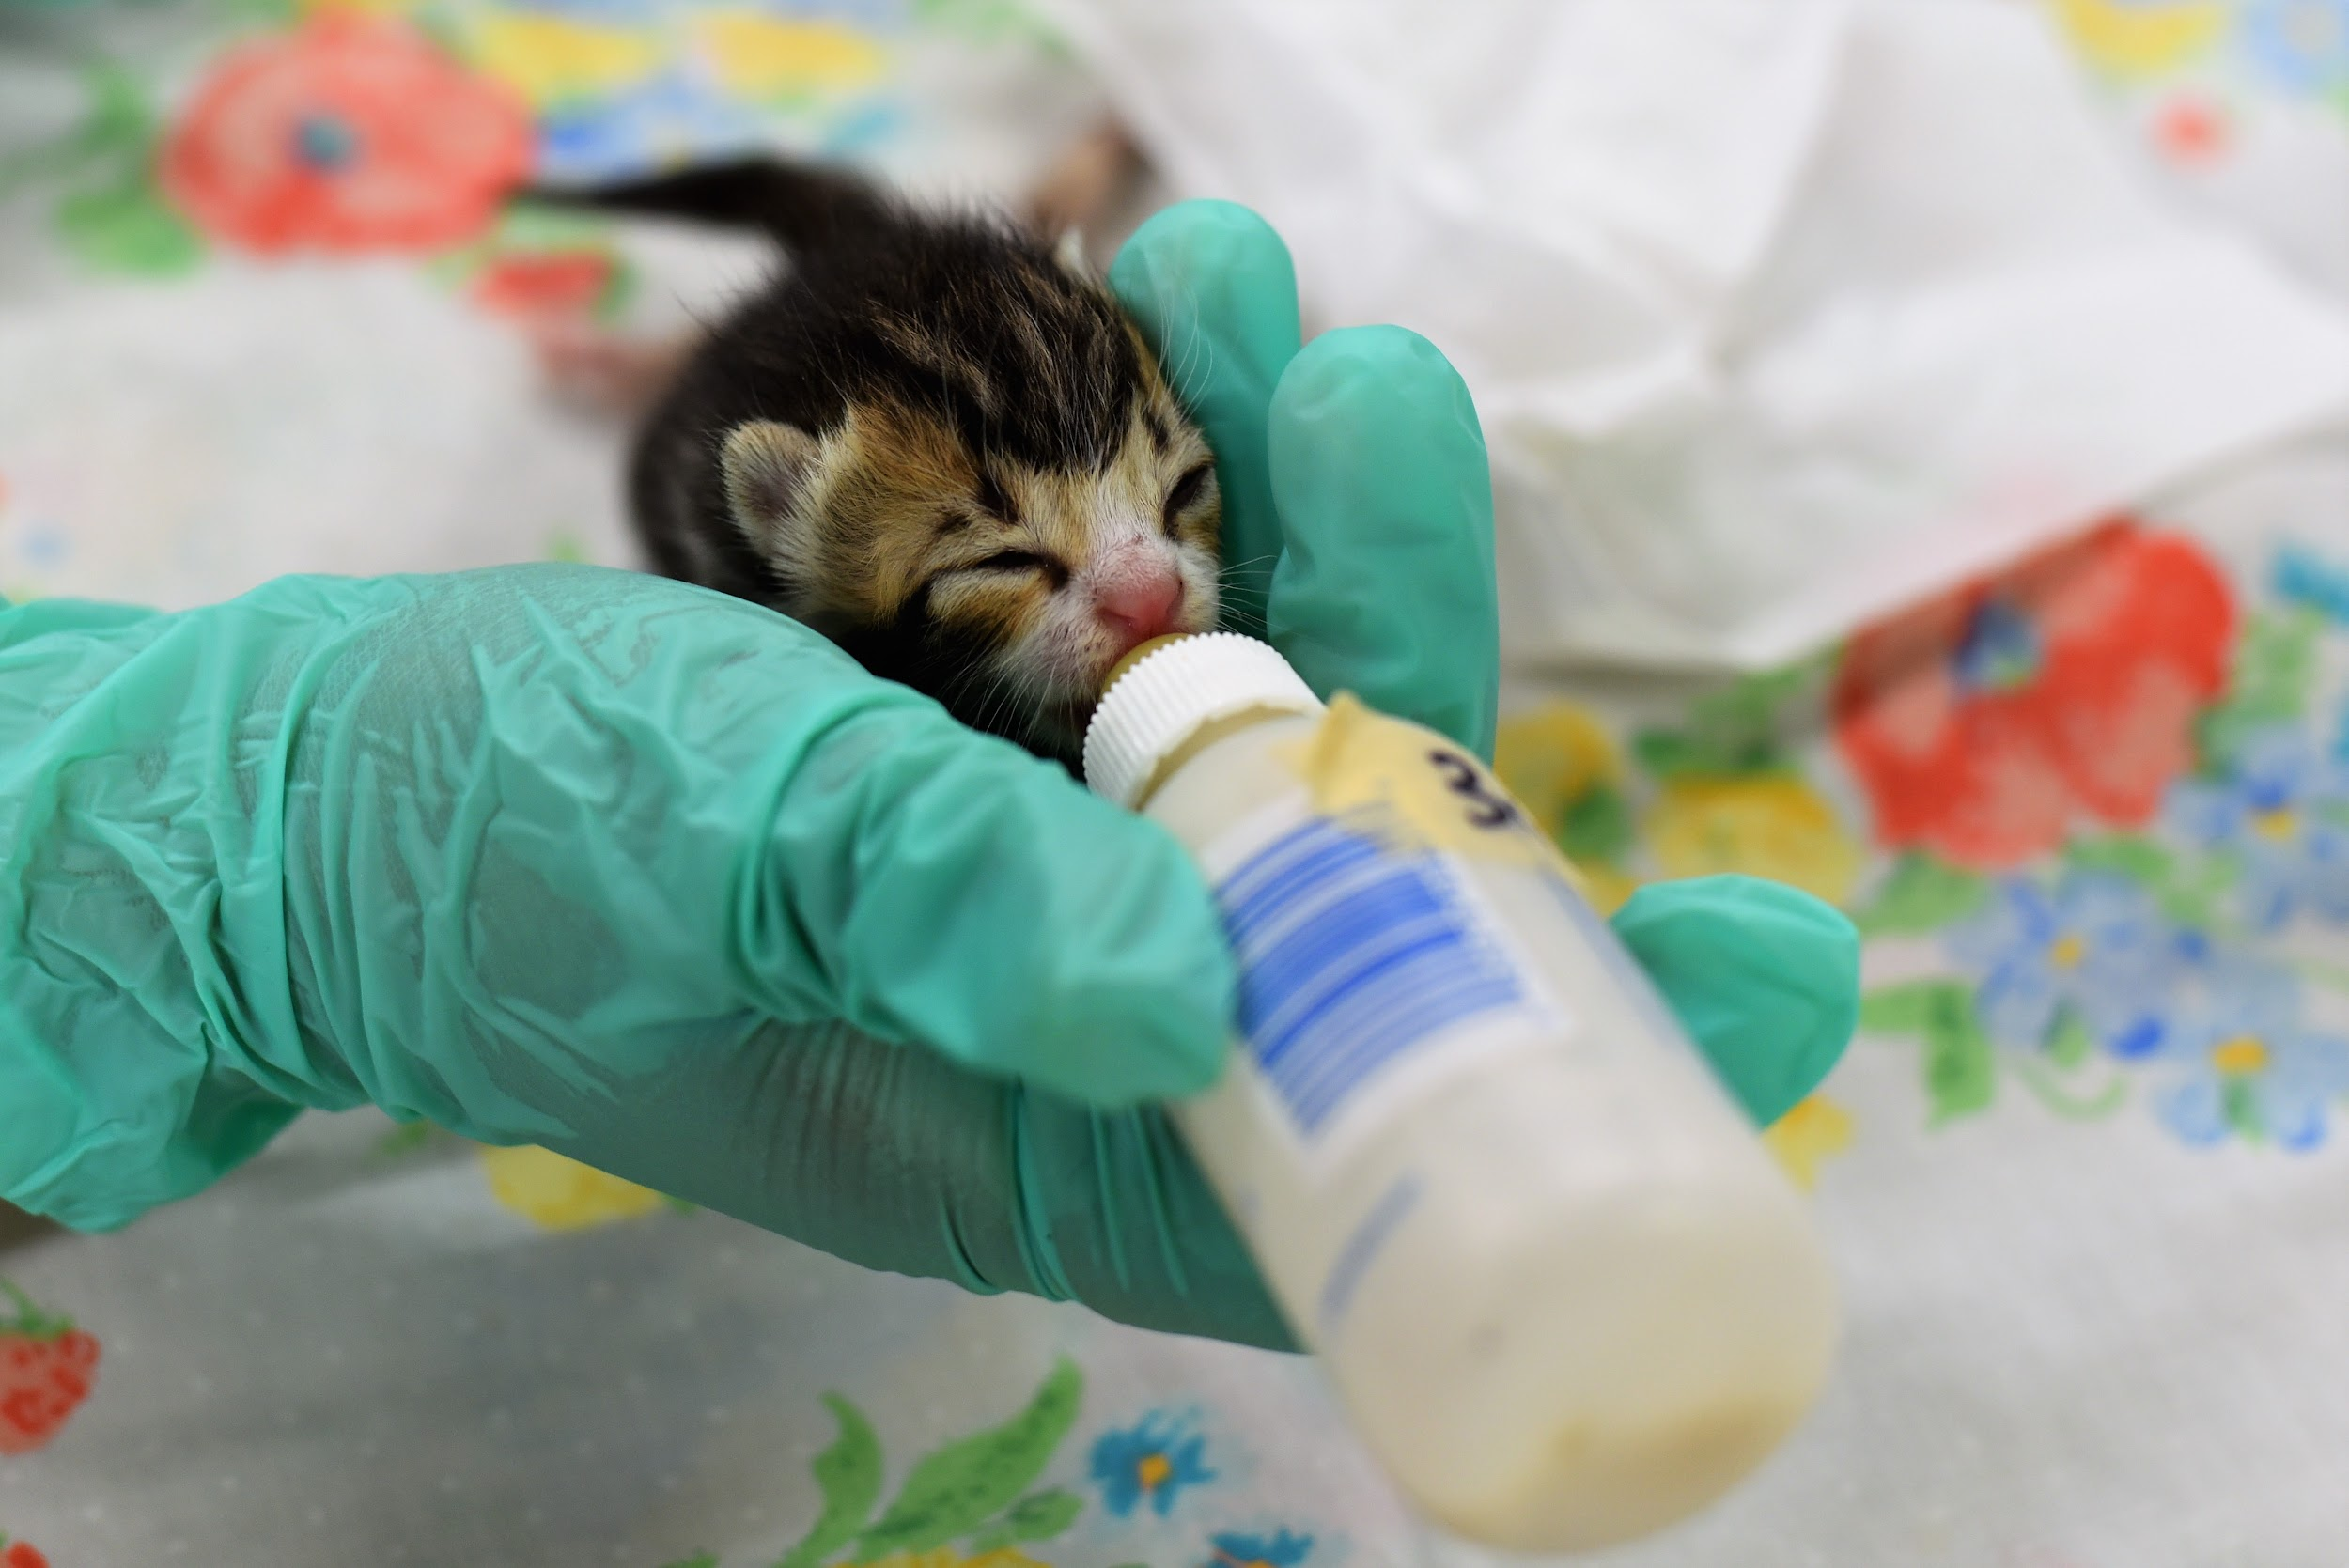

Be very careful not to squeeze formula into the kitten's mouth as this can cause aspiration of milk and predisposes them to pneumonia. If the kitten latches, that's great, but it's okay if it takes a while for her to get the hang of things! Bottle feeding takes practice and patience. Keep trying and follow some trouble shooting tricks if your kitten is taking a little longer to figure out the bottle.

**credit TheKittenLady.org**

Follow this guideline to determine the proper amount and frequency of feeding. Remember that every kitten is different, and this is a guideline--not a rule book!

Troubleshooting Fussy Feeders

- Be sure you're holding the head and body stable to guide her. Kittens don't necessarily understand what you're trying to do, so it's up to you to hold them steady and show them.
- Take a look at your bottle and nipple, and make sure there are no issues such as a nipple that is cut too big or too small, or clumps in the formula that may be causing a blockage.
- Wrap the kitten in a small baby blanket if need be to help her feel focused and swaddled; just make sure she is still in a proper belly-down position.
- Rubbing the face with a cloth or toothbrush can simulate a mother's tongue and help them feel prepared to eat.
- Some kittens prefer to be fed in their beds/enclosures. Some are startled when taken out of their warm beds and will refuse the bottle.
- Some kittens will be encouraged to eat if there is some competition. Feed a fussy kitten next to her brothers and sisters to give her more stimulation to suckle.
- Check out kittenlady.org for more tips. She is great resource for all things kittens.
Weaning Kittens

Weaning can be a difficult time for orphaned kittens and foster parents alike. Around week 5-6, solid food can be introduced. Generally, the easiest way to approach this transition is by mixing kitten formula and wet kitten food and offering to the kitten on the tip of your finger, or in a saucer. During this period, bottle feeding should be continued until the kitten is reliably eating slurry or wet food to avoid malnutrition and weight loss.

Kittens going through weaning are also more likely to have digestive issues as they are transitioning to a new diet. Their stools can become loose, they may become fussier, and they may lose some weight. Ideally, these issues will resolve quickly and without medical intervention, but if diarrhea or weight loss persists for more than two days, please bring the kittens in for urgent evaluation by a veterinarian.

When the kitten is eating wet kitten food reliably, small meals should be offered every 6 hours until week 6, and then can be extended out to every 8 hours around week 7-8. Dry kitten food can also be introduced on a free choice basis after the kitten is eating wet food reliably.

Kitten Health

Record-Keeping

Keeping diligent records is a vital part of keeping foster kittens healthy. It is an invaluable tool that helps us recognize changes in kitten health early. The first signs that a kitten’s health is declining include decreased eating volumes, subtle changes in stools/urination, and most importantly stagnations in weight gain or weight loss. The Foster Department can provide you with a template to make record books for each kitten in your care. With this in mind, it is important to make each kitten stand out individually. If kittens look alike, a small ribbon or string can be tied loosely around their neck, or a small dot of nail polish on the ear in different colors can be helpful (it doesn’t hurt them as long as small amount is used and it is not spilled elsewhere on the kitten!)

1. Weight
Record weights before and after each feeding. This is the easiest way to ensure kittens are eating a proper amount of formula and gaining weight steadily. A kitten should gain weight each and every day.

2. Eliminations
It is a good idea to make a brief note about the urination and defecation of the kitten daily. Since disease can come on very quickly in tiny patients, it is helpful to know exactly when an issue began. Noting the color and consistency of stool, as well as the color of the urine (dark = dehydration).

3. Other changes
Anything else you notice regarding the kitten- activity level, sneezing, any vomiting, or abnormal behavior.

Bring these records with you to each check-up. They are invaluable in helping to diagnose and treat kittens.

Vaccinations

Vaccines are especially important for orphaned kittens who no longer have a queen to provide antibodies through their milk and other natural exposure. The Idaho Humane Society is committed to vaccinating and deworming orphaned kittens on a regular basis and relies on foster parents to bring their kittens in according to this schedule. Vaccines can be given by the Foster Department and takes 5 minutes or less. Vaccine regimens will be continued after adoption until 16 weeks of age.

FVRCP/HCP vaccine given first at 4 weeks of age, then every 2 weeks until 16 weeks of age. This protects kittens against panleukopenia virus, a life threatening diarrhea virus.

Pyrantel dewormer orally starting at 4 weeks of age, then every 2 weeks until 16 weeks of age. This ensures that kittens do not have parasitic infestations which can contribute to digestive issues and malnutrition.

Rabies vaccines cannot be given until kittens are 12 weeks old. This will generally occur after adoption, but if for some reason kittens are still in foster after 12 weeks, they may receive this vaccine.

Common Problems

1. Weight Loss/Decreased Intake
Your record book will help you to recognize when your kitten’s weight is either stangnant or decreasing. This is always cause for concern. The simplest reason would be that there are issues at feeding time. Use the troubleshooting guide to help ensure that bottle feeding is as successful as possible. Double check that your nipple and bottle are clean and not damaged. Mix up a new batch of formula following the directions and keep trying. Make sure the kitten is warm and clean.

However, if the kitten’s intake does not increase, and her weight is not increasing appropriately, other issues may be at play. Bring the kitten in for a veterinary exam as soon as possible to rule out other causes.

2. Diarrhea
Diarrhea is an extremely common issue in bottle-fed kittens for many reasons. Even though kitten milk replacer is our best option, it does not perfectly mimic nursing. There is a lack of normal microbiota from the queen. Kitten stool is normally fairly soft, but if it is liquid, mucusy, bloody, or dark/black, this is abnormal and cause for concern. If diarrhea continues for more than two days, you should bring the kitten in for a veterinary exam.

Some common causes of diarrhea are dietary changes (weaning), overfeeding, improperly mixed formula, parasites, bacterial overgrowth, and finally viruses. One very concerning cause for diarrhea is called Panleukopenia Virus. Panleukopenia virus is a potentially deadly virus spread from cat to cat through fecal-oral contamination. Kittens are extremely susceptible to this if exposed. The virus affects the immune system and the digestive tract causing diarrhea, fever, lethargy, vomiting, and can even cause sepsis and death in a large percentage of affected kittens. A veterinarian may run a quick in-house test to rule this out when kittens are seen for diarrhea. Panleukopenia virus is one of the many important reasons to practice good hygiene between kitten litters and to avoid contact between foster kittens and your personal pets.

Treatments for diarrhea will be prescribed according to the most likely cause but may include probiotics, fluids, antibiotics, etc.

3. Upper Respiratory Infection
Sneezing and/or nasal and ocular discharge is a common sign of upper respiratory infection (URI). URI is a very common disease in cats and kittens and is essentially a cold.. Most kittens will get over this with time, but sometimes as secondary bacterial infection develops resulting in colored (yellow or green) nasal discharge and antibiotics may be dispensed. Please schedule an appointment with the shelter veterinarian if you think your kittens may have URI.

4. Aspiration Pneumonia
Sometimes if kittens have trouble swallowing, or if milk gets forced into their mouths, milk can go down their windpipes and into their lungs. The foreign material in the lungs sets up an inflammatory reaction and leads to pneumonia. This requires urgent veterinary attention. Signs of this include a gurgly sound when breathing, rapid or difficulty breathing, and/or nasal discharge. Please come to the shelter or schedule an appointment ASAP with the shelter veterinarian if you think your kitten may have this condition.

5. Ear Mites
Kittens with ear mites will scratch at their ears and shake their heads. However, sometimes, kittens may get used to the mites and not show any discomfort at all. Within the ear canal, there will be dark debris that looks like coffee grounds. If you notice these signs in your kittens, please schedule an appointment with the shelter veterinarian to get treatment for your kittens. Ear mites are contagious amongst cats, and are another good reason to avoid contact between your household pets and foster kittens.

6. Ringworm
Ringworm is a highly contagious fungal skin disease, most commonly found on found on the head and extremities in kittens. It is transmissible to humans. Ringworm is treatable and is never fatal, but needs to be treated early due to its contagious nature. Ringworm causes patchy hair loss with crusty skin. If you notice your foster kittens having any hair loss, please make an appointment to have your kittens seen by a veterinarian.

7. Fading Kittens
Occasionally, one or more kittens in a litter that originally seemed healthy and vigorous will begin to “fade” after a short time. They may stop growing, start losing weight, lose interest in eating, and seem overall lethargic. They may or may not show other signs. “Fading kitten syndrome” is an umbrella term used to describe a poorly understood syndrome which likely involves congenital or acquired illness unique to neonatal kittens. Kittens can fade very quickly. Early intervention by a veterinarian is imperative, however, even with intensive treatment, some fading kittens may die. Alert the Foster Department immediately if you think your kitten is fading.

Signs can include:
- Low body temperature that does not respond to heat supplementation
- Lethargy; slow moving kittens or even non-responsive kittens
- Gasping for breath, open mouth breathing
- Meowing incessantly

Immediate treatment you can initiate:
- Get them warm. Swaddle the kitten in a warm towel and sit the kitten on a heat disk or heating pad.
- Once the kitten is warm, help raise the kitten’s blood sugar. Place a few drops of Karo syrup on the kitten’s tongue or roof of her mouth
Emergencies
Unfortunately, emergencies do happen. During the hours that IHS is open, the cat should be immediately brought into the shelter if an emergency does occur. During evening hours or holiday closures, we will not be able to take care of the kitten. Please follow the instructions in your foster parent handbook to call Vidaah to receive real time advice from a veterinarian. Emergencies include:
- Fading kittens
- Continuous vomiting: kittens that have been unable to hold down anything for more than 3 feedings or 12 hours
- Trauma: Stepping on a kitten, animal attack, falling from a high surface. Trauma is a true emergency if the kitten has been significantly injured, has an obvious broken limb, or is actively bleeding
- Labored or open mouth breathing: Not just nasal congestion, but the kitten is truly struggling to breathe
- A kitten that is unresponsive

If you are in doubt about a health issue regarding your foster kittens, call the Foster Department. If you think it is a true emergency, bring the kitten to IHS immediately.

Helpful Charts

Kitten Stages of Life

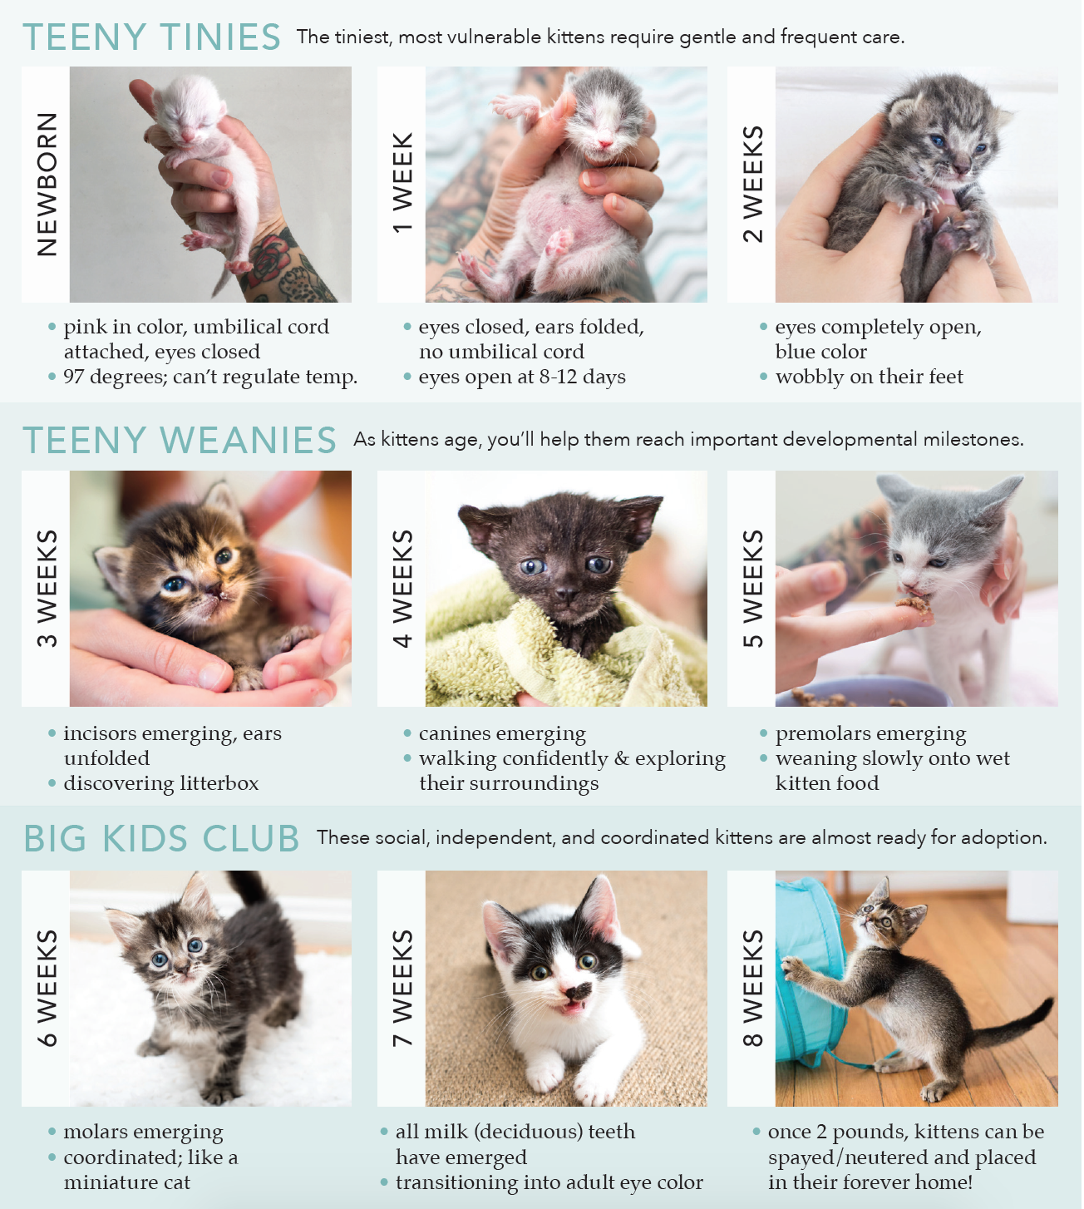

Feeding Guide

